**Launch Cloudant DB**

|  |  |
| --- | --- |
| Date | 03 Nov 2022 |
| Team ID | PNT2022TMID34450 |
| Project Name | Virtual Eye - Life Guard For Swimming Pools To Detect Active Drowning |

**Launch Cloudant DB**

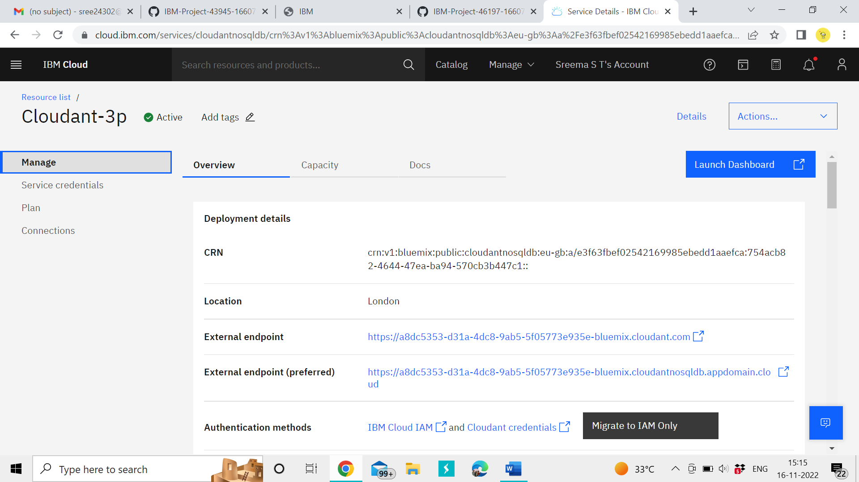

My Cloudant DB launches

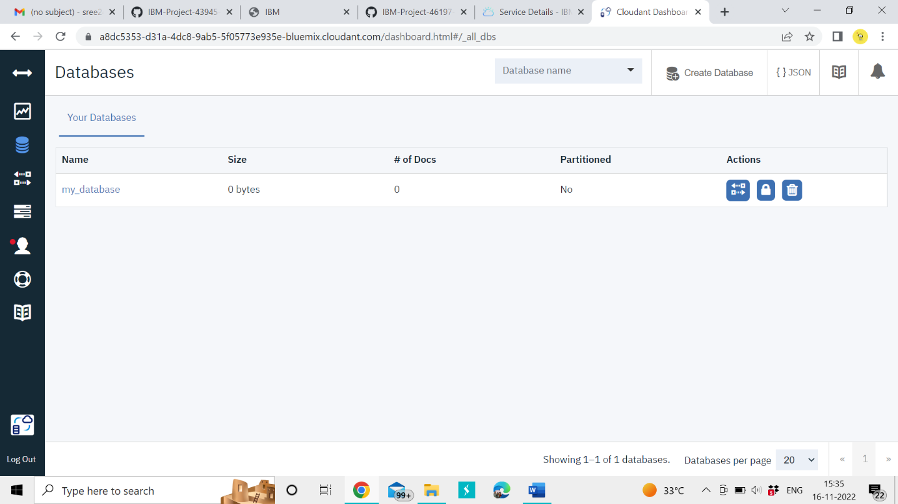

Let's create the Database Now

Same procedure followed by my team members

**Team ID** : PNT2022TMID34450

**Team Leader**: Jone Abutelin B

**Team Member1**: Femi Priya K.C

**Team Member2**: Sreema S.T

**Team Member3**: Suthi R